**Geospatial Analysis of Hong Kong for Optimal Sportswear Store Location**

Author: Preston Chou

Date: February 26, 2021

**1. Introduction**

This project aims to assist in choosing the optimal location in Hong Kong for a sportswear store. The sportswear market has been growing in Hong Kong due to more active lifestyles, the proliferation of gyms and certain related fashion trends (e.g. athleisure, activewear). Starting a sportswear business seems promising, but assuming that one’s business model involves brick-and-mortar stores, a sportswear store’s location is a crucial success factor.

In this data analytics project, the primary metric used to assess an area’s potential will be its number of fitness, clothing or shopping-related venues. Another metric will be each area's most common venue types. A greater number of venues in an area implies greater interest in fitness lifestyles and/or fashion, and the presence of a “fitness/fashion ecosystem.”

The project intends to help existing sportswear companies looking to optimize their current location strategy, new start-ups looking to enter the market, and Hong Kong sportswear market analysts.

**2. Data**

**2.1 Data Sources**

This project will utilize the below data sources:

* Hong Kong Constituency Areas GeoJson: Border data for each of Hong Kong’s Constituency Areas and corresponding Districts
  + Sourced: Hong Kong Geodata Store <<https://geodata.gov.hk/gs/view-dataset?uuid=ddd39cbe-5f10-4dbd-96e7-7a4883e37388&l=en&sidx=0>)>
* Nominatim Geocoder API: Coordinates (latitude & longitude) of Hong Kong areas
* Foursquare API: Venue data for each of Hong Kong’s areas

**2.2 Data cleaning & processing**

**2.2.1 Hong Kong Constituency Areas GeoJson**

The Hong Kong Constituency Areas GeoJson provides a lot of useful data, including each of Hong Kong’s Constituency Areas in 2019, the Districts they belong to, and the coordinates for their borders.

However, a disadvantage for using the Constituency Areas as the basis for analyzing Hong Kong is that some of the areas are used only in the context of being a constituency, rather than carrying significance in an economic or demographic sense. The names of some Constituency Areas may be obscure for our Nominatim Geocoder API, which is responsible for finding coordinates given the name of the area. We will find some ways to handle these issues.

We will extract the Constituency Areas and Districts from the file and put them into the columns of a new Pandas dataframe:

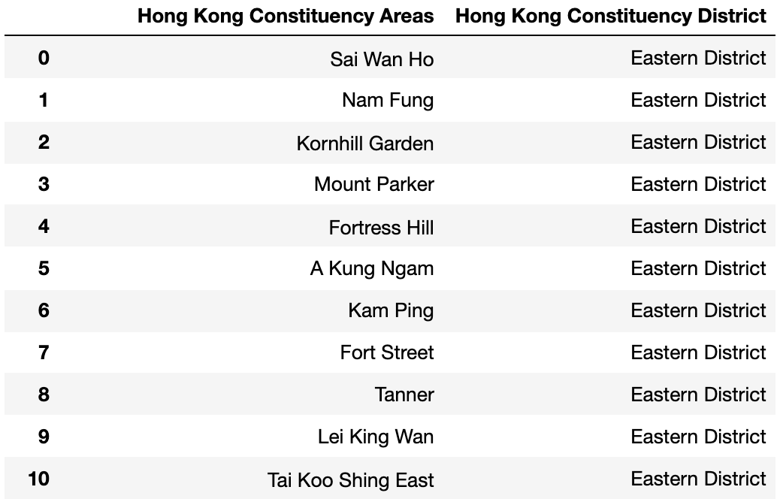

**2.2.2 Nominatim Geocoder API Coordinate Data**

The next step is to acquire the latitude and longitude coordinates for each Constitutional Areas. The Geocoder API returns the most accurate coordinates when the input address includes the constituency area, followed by the district and the city ('Hong Kong'). However, this input format yields more 'None' values, which we need to deal with later on. Alternatively, the input address can only include the constituency area and the city. This input format yields far less ‘None’ values, but the accuracy of the coordinates is poor, so let’s go with the first format for now. We will then append the latitude and longitudes to the dataframe:

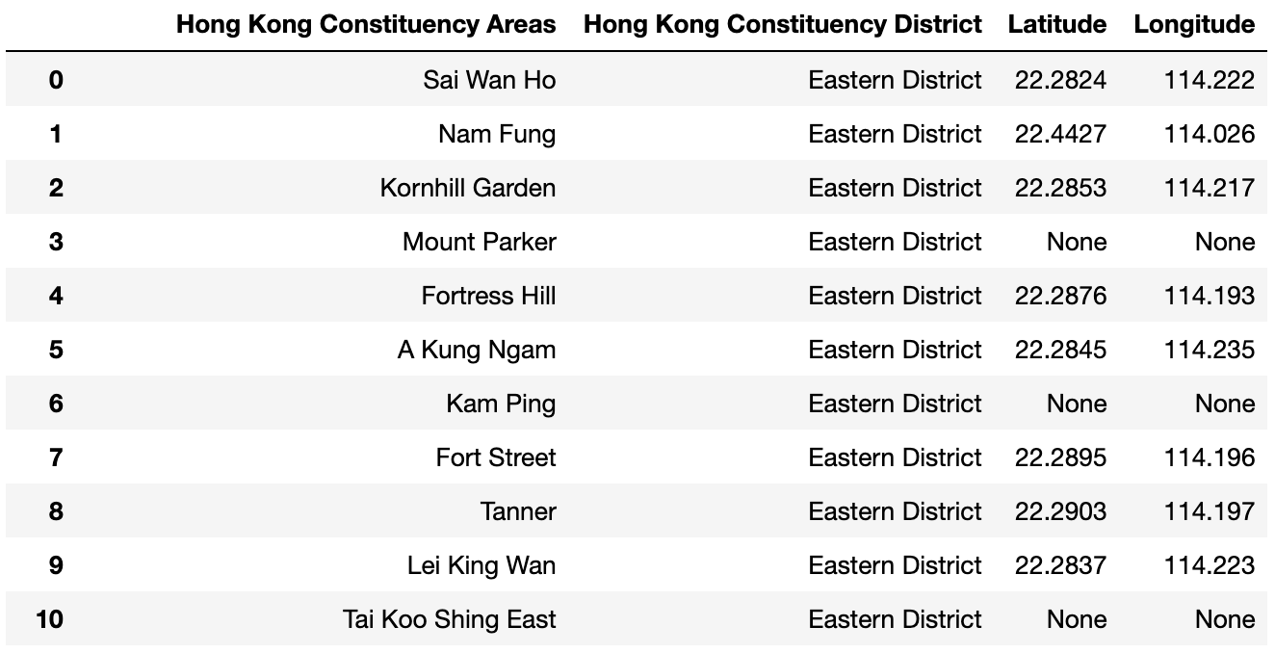

The locations for which the Geocoder API does not return coordinates can be split into three main categories.

The 1st category of these locations includes the names that contain very specific sub-area terms (e.g. North, South, East, West, Upper, Lower). For these instances, we can eliminate the sub-area terms and consolidate the names to one general name (if its corresponding sub-area location is located, then we simply delete the unidentifiable location).

The 2nd category conjoin two or more names (via commas or ampersands). We can form separate names for this category.

The 3rd (most underwhelming but most numerous) category includes names that are simply too obscure for the Geocoder API. Many of these names are only used in the context of being constituencies and lack geographically significance in business terms. We can try to input their address to the Geocoder API as comprising of the Constituency Area name followed by 'Hong Kong'.

But given the unreliability of the API with this input format, we will check to see if the coordinate is contained within the area boundaries as given by the GeoJson file. We can simply eliminate the rows that are outside the boundries since most (if not all) of them are extremely small and closely neighbor other more significant and identifiable areas.

**2.2.3 Foursquare API Venue Data**

For each Constituency Area, we want to know which venues exist in the vicinity of the Area’s coordinates. We will acquire this venue data through the FourSquare API. We will input the names and coordinates of each Area into the API, acquire up to 300 venues from a 500m radius. We create a new dataframe with a row for each venue.

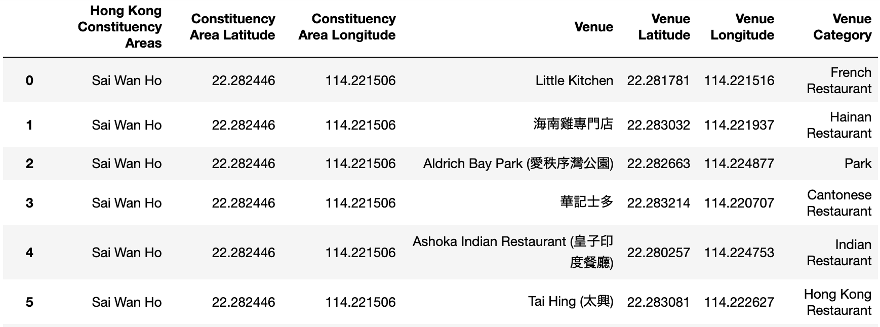

Based on this dataframe, we will produce a new dataframe with dummy values for the venue categories. Scanning through the venue categories, we will filter by only including categories with fitness, clothing or shopping-related keywords that indicate relevancy for our objective – opening a sportswear store. The chosen keywords are:

* Sports
* Sport
* Sporting
* Fitness
* Gym
* Studio
* Field
* Pool
* Martial art
* Court
* Clothing
* Fashion
* Outdoor
* Shoes
* Shopping

We then add a column listing the name of the Constituency Area, group the dummy values by sum according to the Area names. Additionally, we add a column listing the Total number of venues for each Constituency Area – this total value will be useful for our choropleth map.

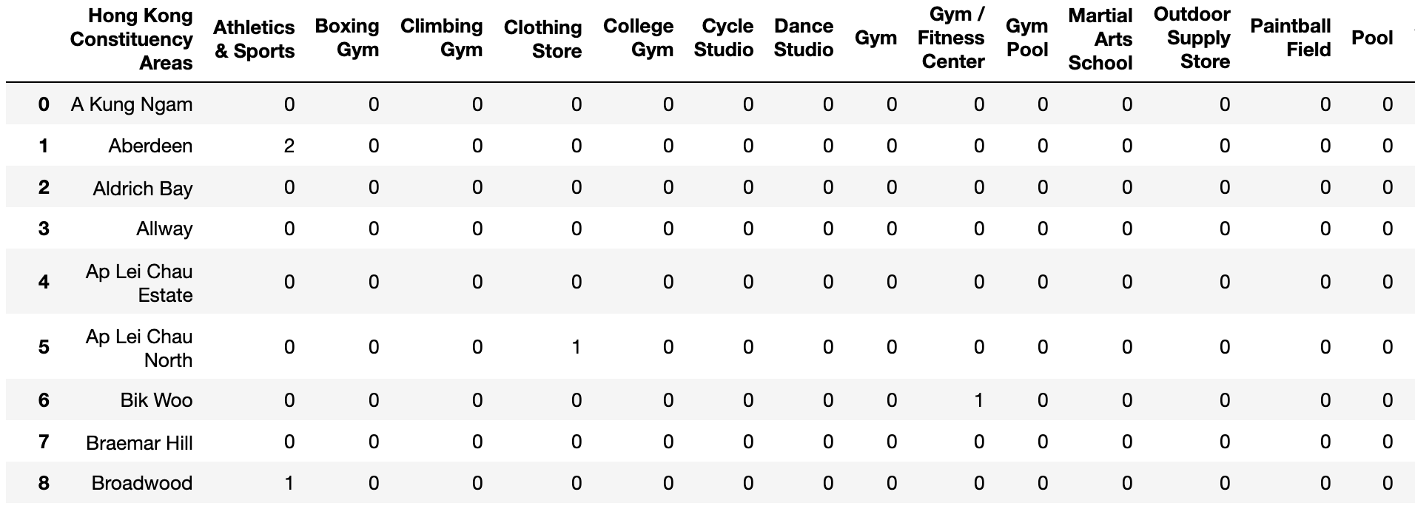

**3. Data Analysis & Results**

Our data analysis phase has 2 objectives. The 1st objective is determining which areas in Hong Kong have greater numbers of fitness, clothing or shopping-related venues. Areas with higher numbers of venues are more likely to be promising sportswear store locations, since they probably have relevant economic-activity and higher consumer demand.

The 2nd objective is understanding the areas’ venue-makeup. For example, some areas may have more gyms, others may have more clothing stores, while others may have many shopping malls. This provides another dimension to assess the suitability of an area.

The 1st objective is more straightforward, since we already have 'Total' venue numbers for each area. For the 2nd objective, we will employ K-means clustering to categorize the areas by their venue makeup. For this purpose, we will identify the top 10 most common venue categories for each area.

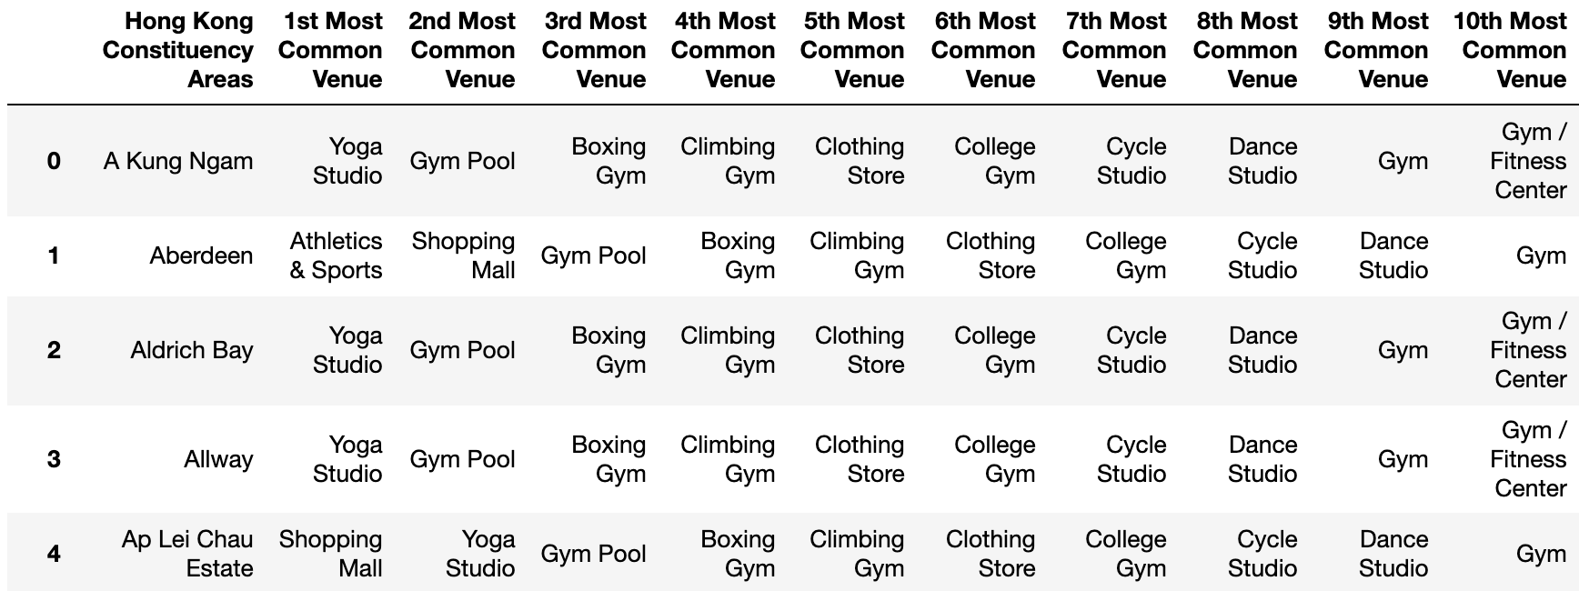

**3.1 K-Means Clustering**

To conduct K-Means Clustering analysis (through the Scikit-learn library), we need to decide on an optimal number of clusters – the K-value.

**3.1.1 Elbow method**

We can determine the optimal number of clusters through a couple methods, the first being the Elbow Method. In the Elbow Method, we run K-Means clustering for a range of K-values. For each K-value, we find the average of the squared distances for each point from the center of its selected cluster. In the plot, we choose the K-value after which the line appears to descend in a more linear pattern.

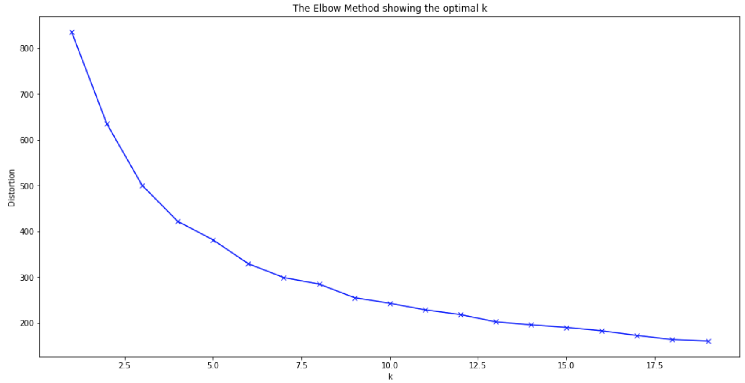

Unfortunately, the curve does not have a very sharp elbow (an 'ideal' elbow) at which we can easily choose a K-value. However, the line begins to resemble in a straight line in the 10-15 range. We should use another method to better decide on the precise K-value to use.

**3.1.2 Silhouette Analysis**

The second method is the Silhouette Analysis, also acquired through the Scikit-learn library. This method measures the degree of separation of the clusters from each other. We calculate a score for each sample point, reflecting its distance from other clusters.

The scoring range runs from -1 to +1. -1 implies that the sample point is much closer to another cluster and is therefore incorrectly assigned. 0 implies that the sample point is right on the border between 2 clusters. +1 implies that the sample point is very close to its own assigned cluster. So the higher the score, the more accurate the clustering!

We will use a range of K-values from 2 to 15 (since the elbow curve shows the curve resembling a straight line in the 10-15 range). Each cluster has its own silhouette coefficient, and an average silhouette score is calculated for a given K-value.

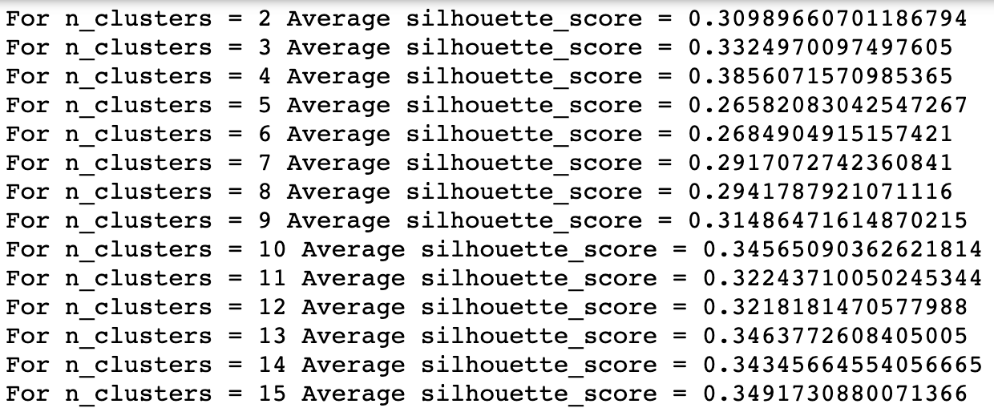

We will also produce a silhouette plot that shows the silhouette coefficient, and the thickness of the plot reflects the size of the cluster size.

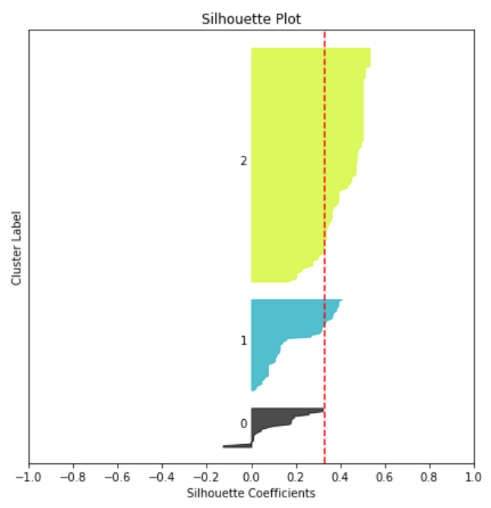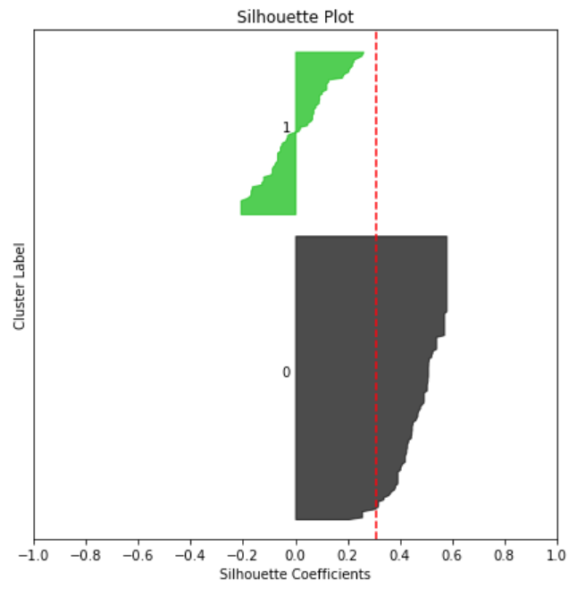

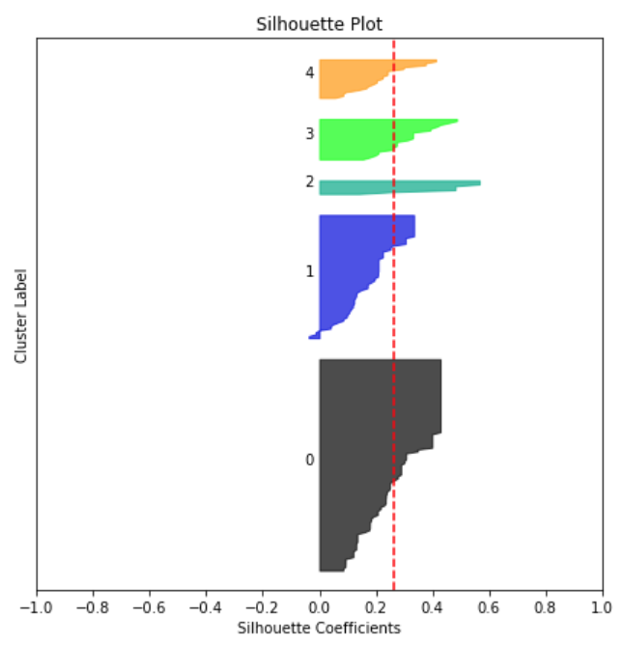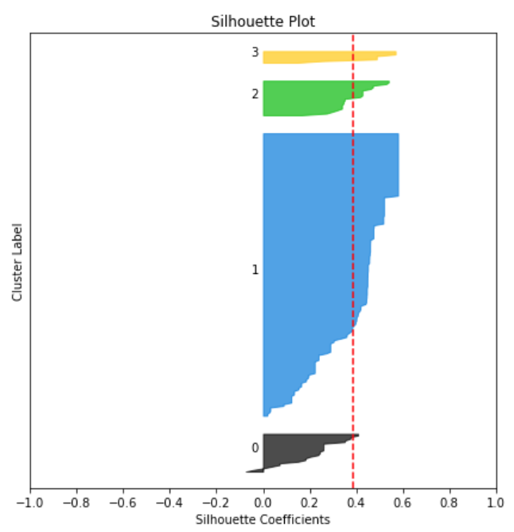

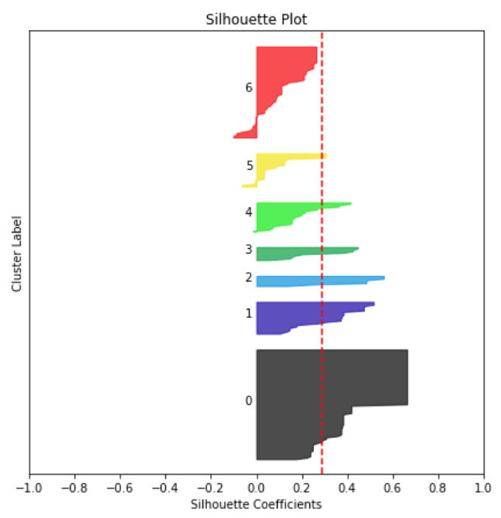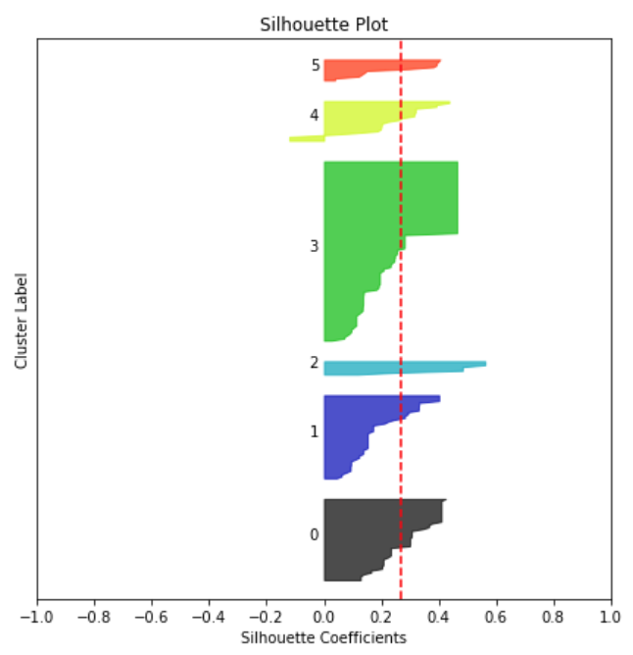

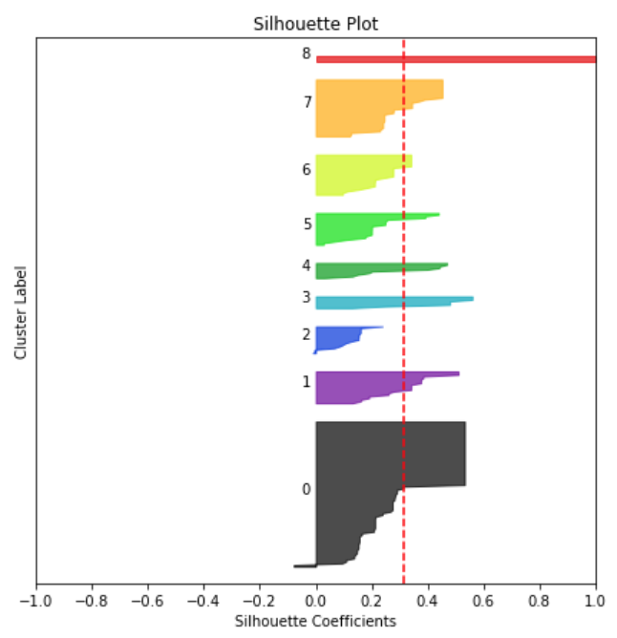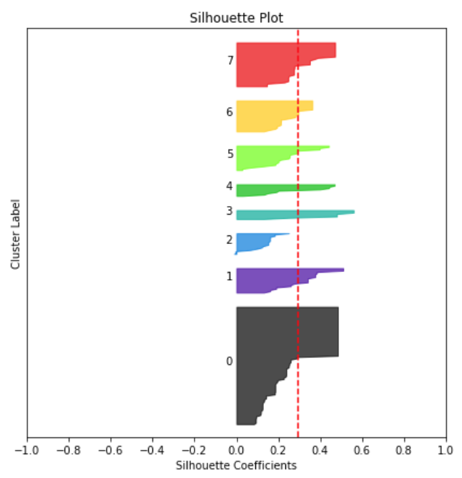

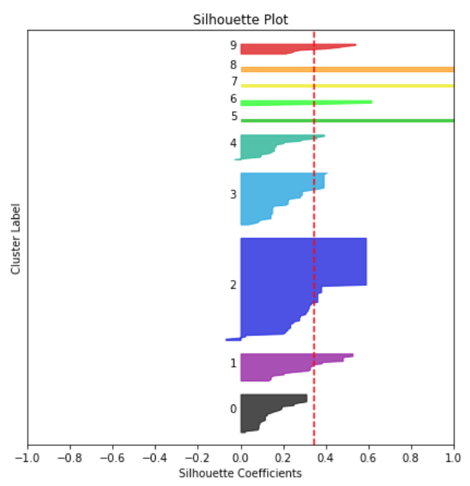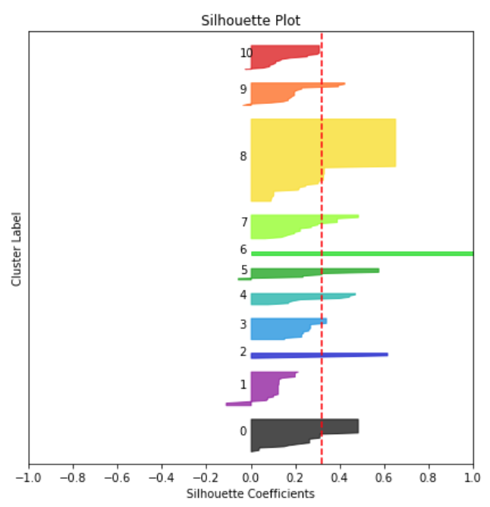

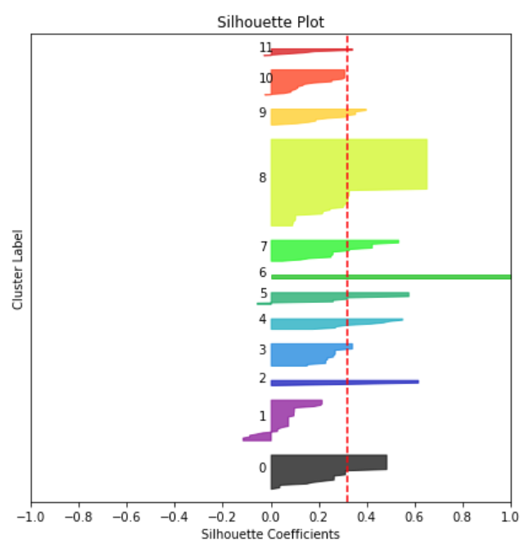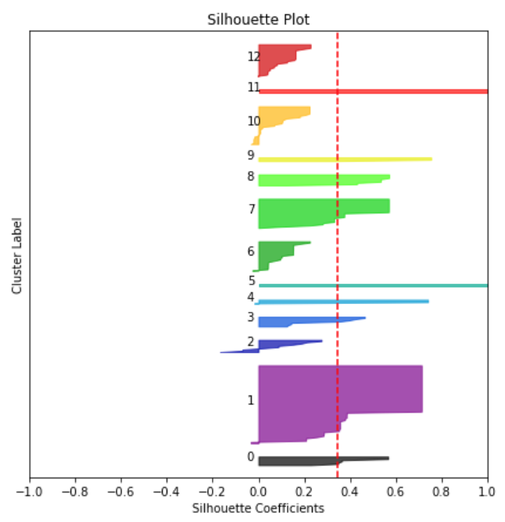

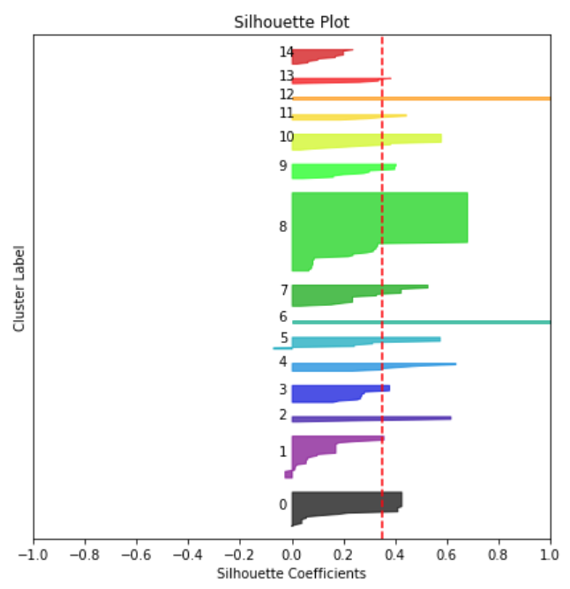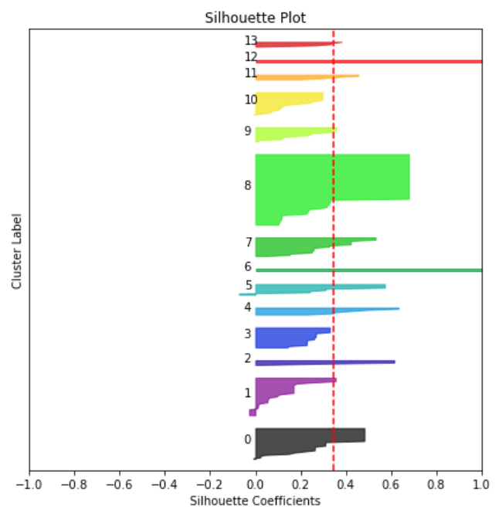

A K-value of 15 offers a high silhouette score, but we are also concerned with the risk of overfitting. 13 clusters seems to also yield a good silhouette score, so we will use K-Means Clustering to segment the areas into 13 different clusters.

**3.1.2 K-Means Clustering Analysis**

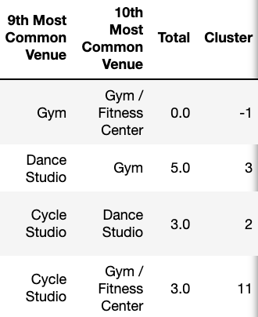Using the K-Means Clustering algorithm, we assign a cluster label (from 1-13) to each Constituency Area that has a non-0 value for its total number of venues. For Constituency Areas that have 0 relevant venues, we will assign a cluster label of -1.

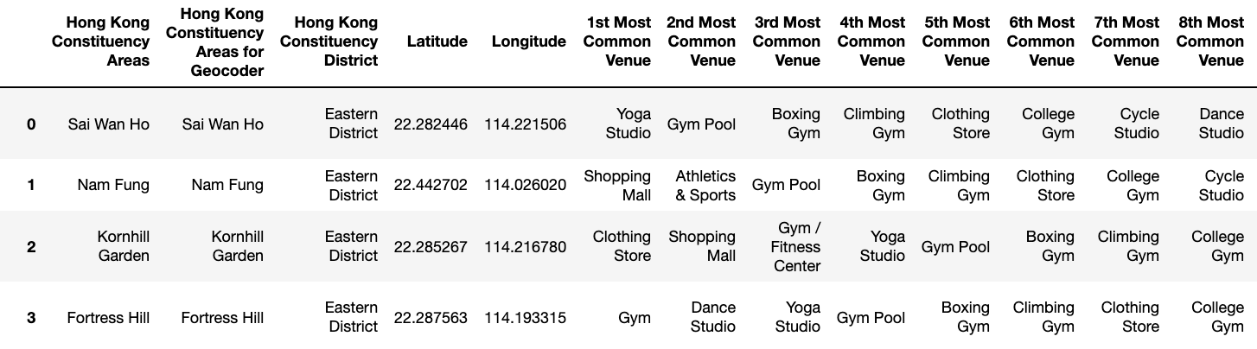

**3.2 Geospatial Analysis**

**3.2.1 Map generation**

We present the results of our analysis through maps via Folium. With choropleth maps, we will use shadings of blue to indicate different ranges of venue numbers in each area (darker meaning more numerous). We will then use circle markers that shows each area's name, district and cluster label. The circle marker’s color corresponds to its cluster.

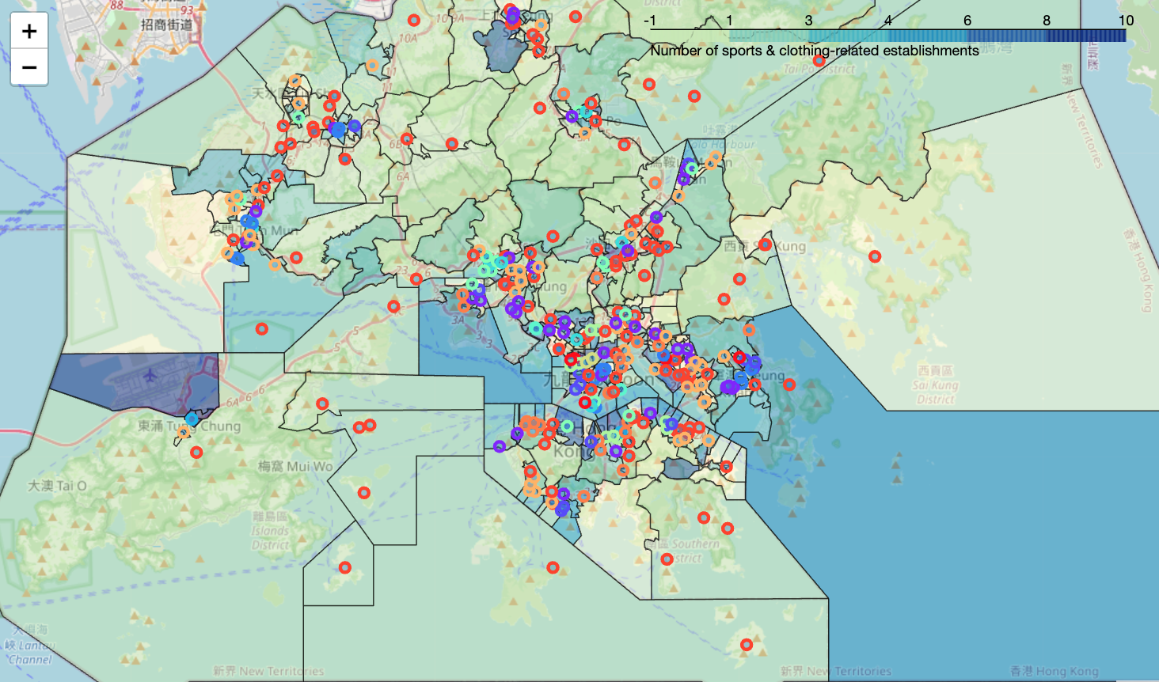

**3.2.2 Cluster observation**

We will filter the dataframe to only include areas belonging to each separate cluster. This way, we can observe the most important and discriminating features of each cluster.

**Cluster 1**

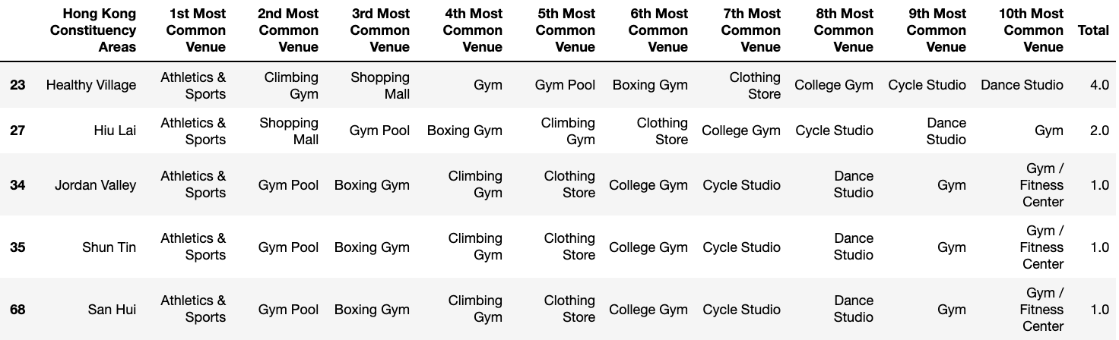

**Cluster 2**

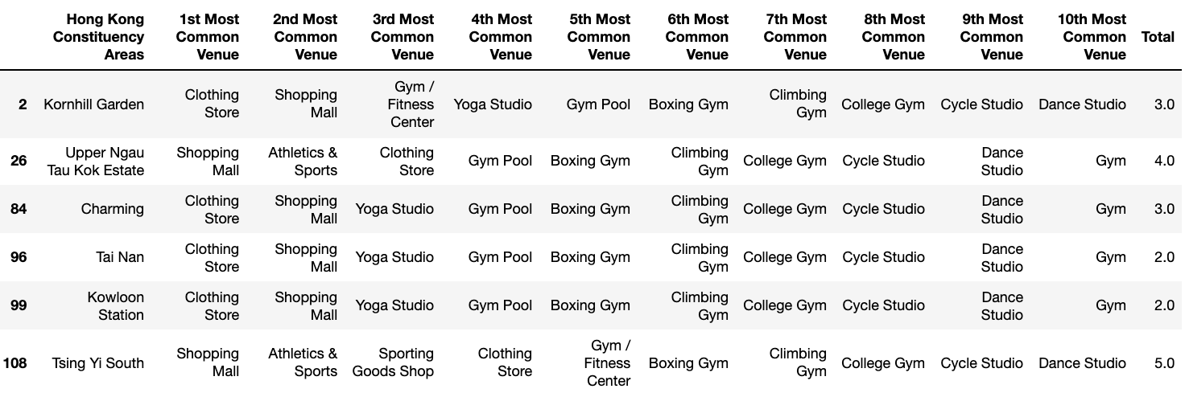

**Cluster 3**

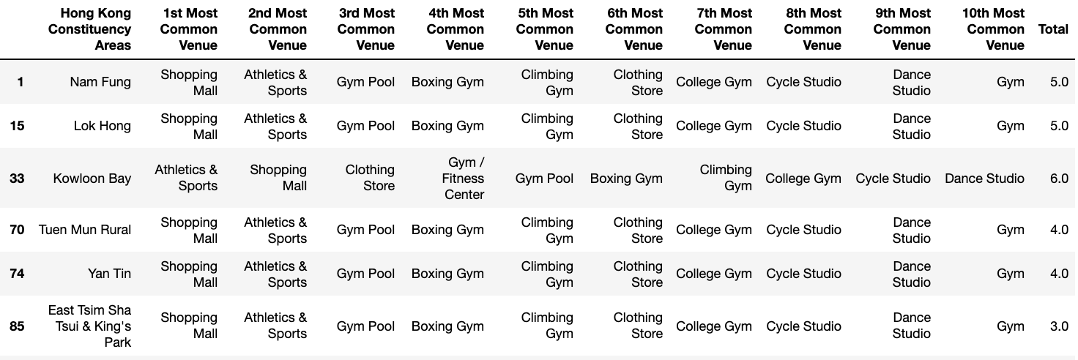

**Cluster 4**

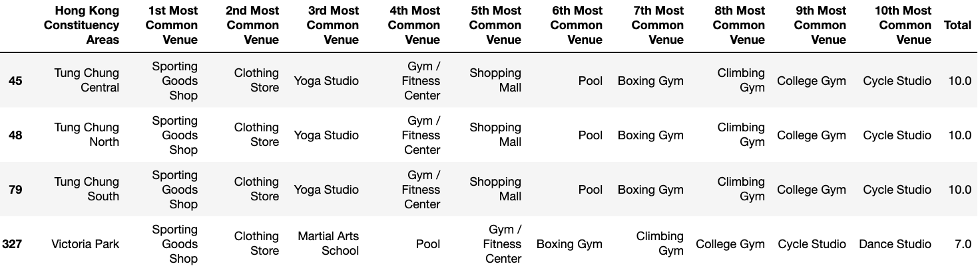

**Cluster 5**

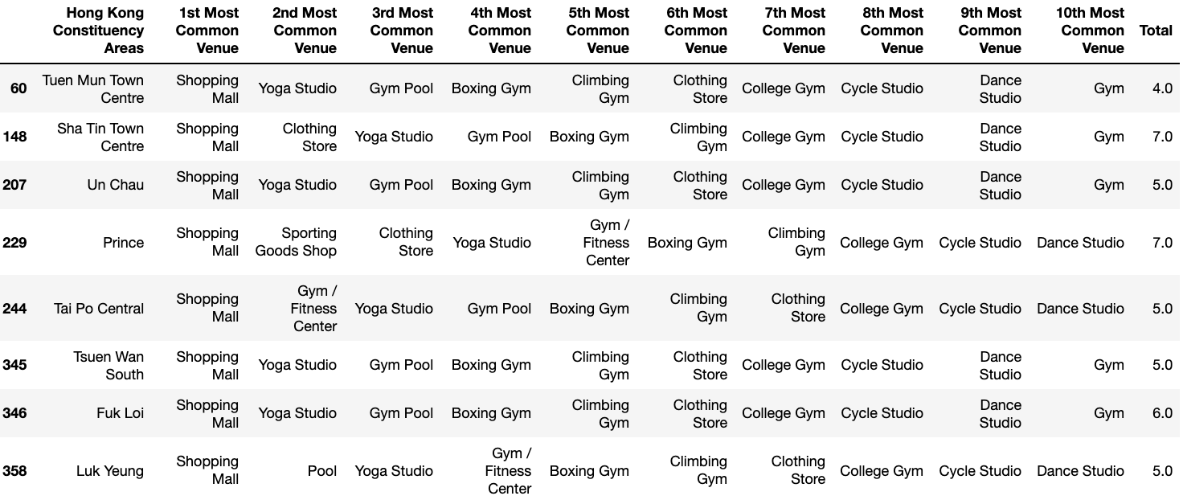

**Cluster 6**

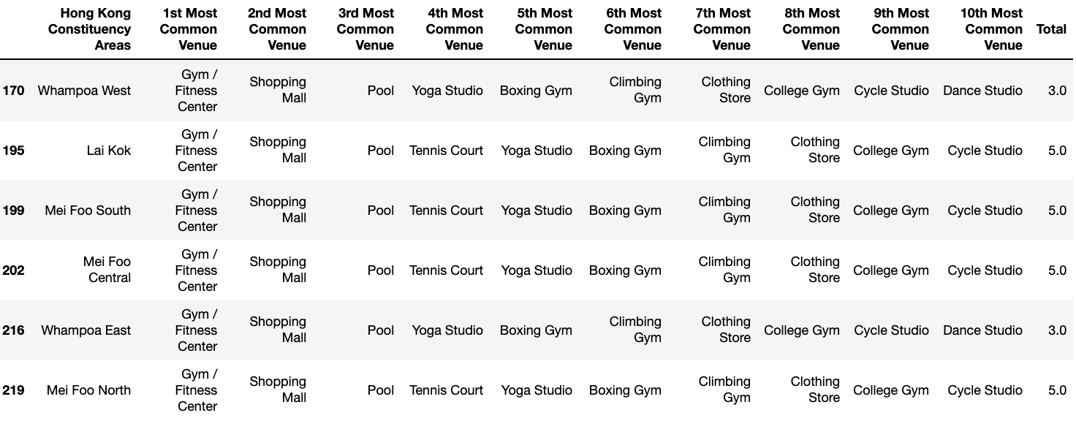

**Cluster 7**

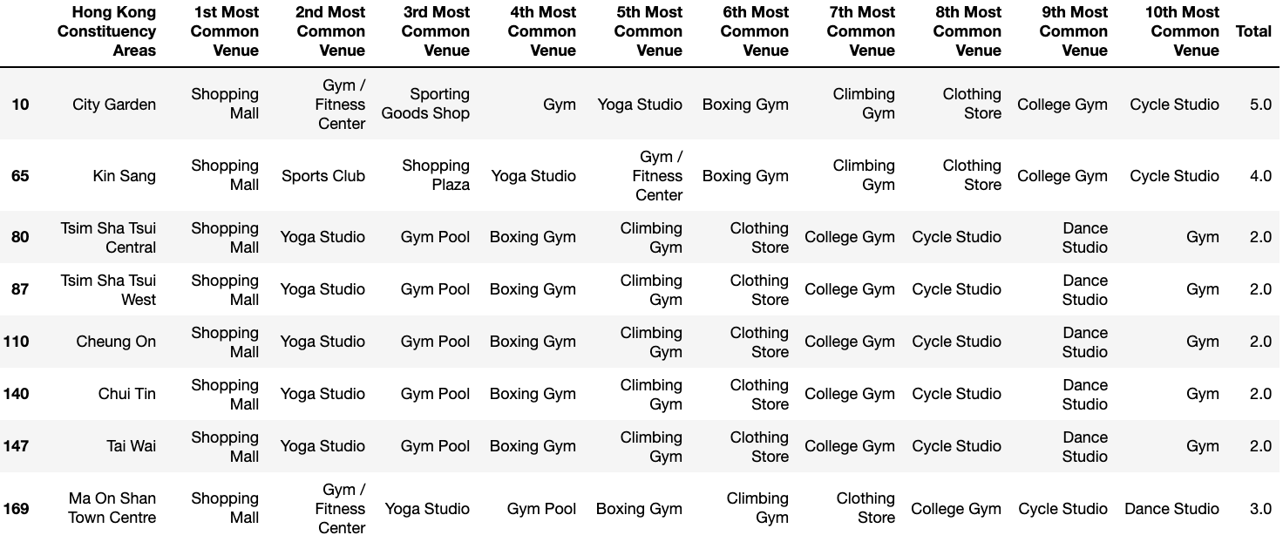

**Cluster 8**

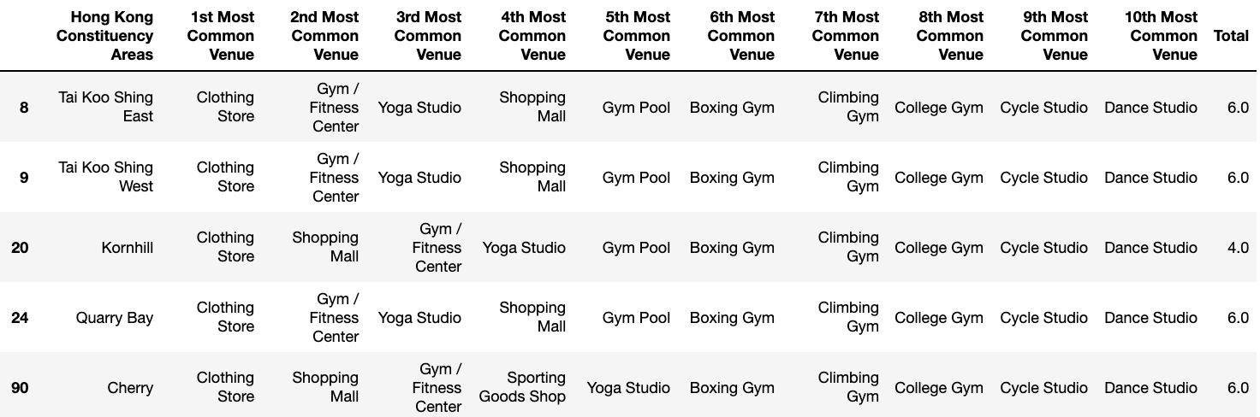

**Cluster 9**

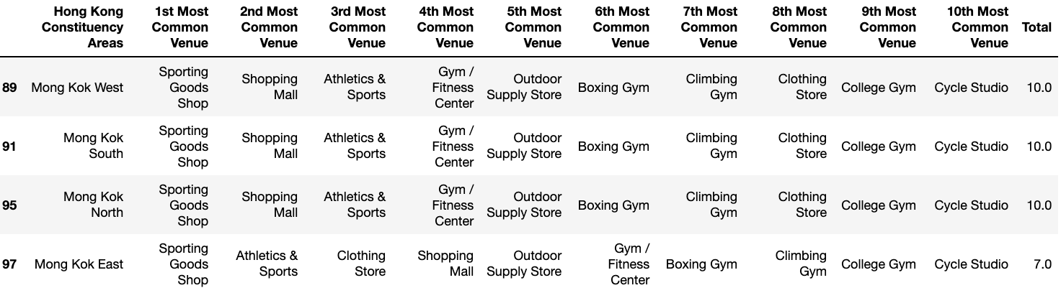

**Cluster 10**

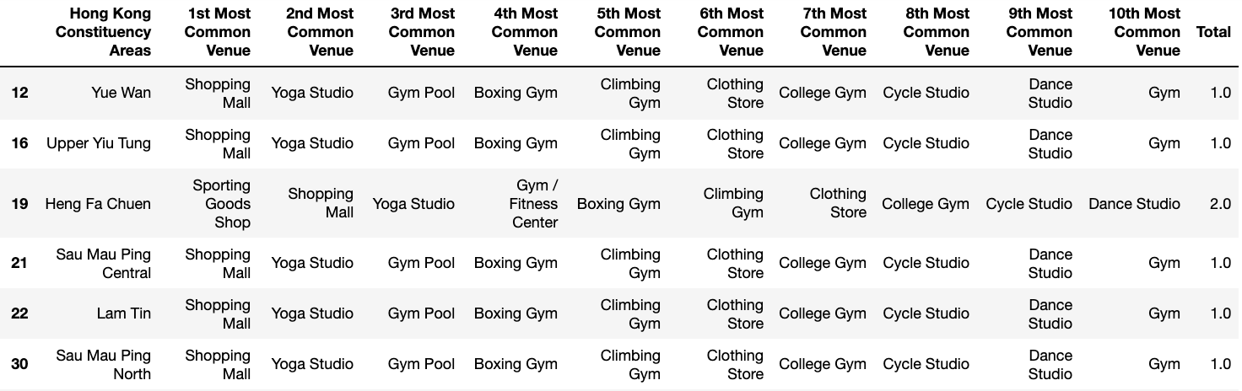

**Cluster 11**

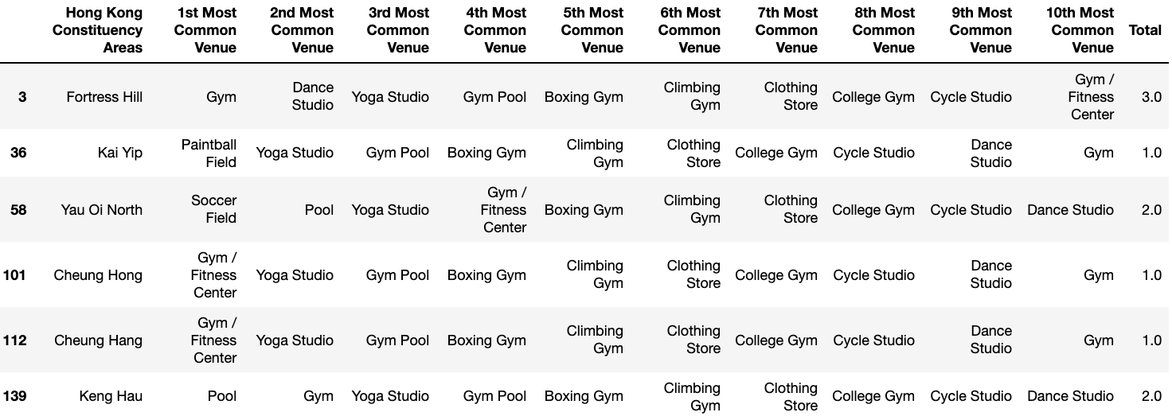

**Cluster 12**

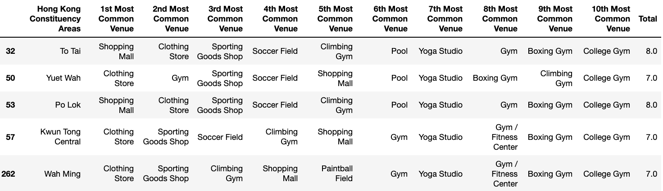

**Cluster 13**

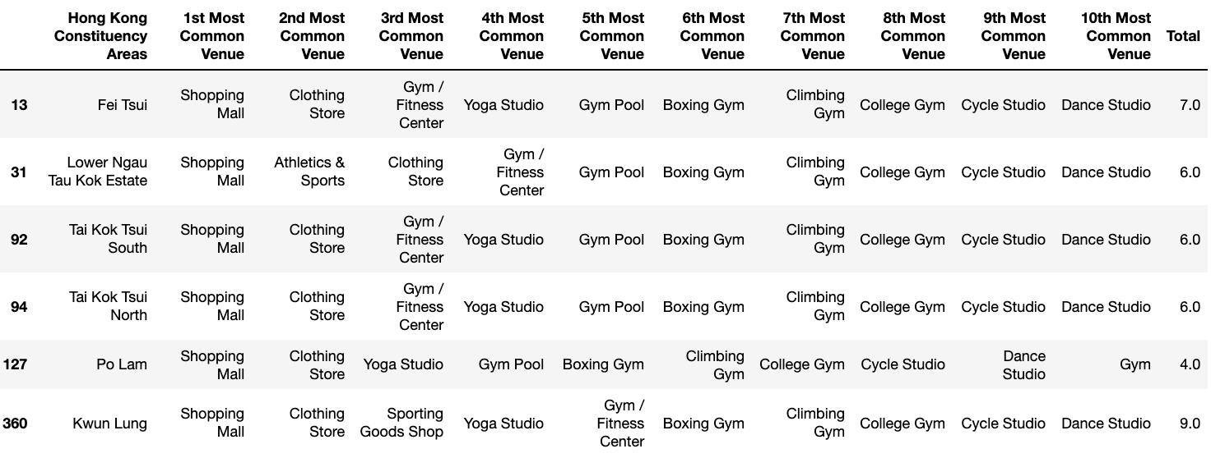

**4. Discussion**

The results of the geospatial analysis yield many useful insights for understanding the business potential of the various areas in Hong Kong and the optimal sportswear business strategy for these areas.

Through the choropleth map, we can tell that areas along the northern edge of Hong Kong island have a darker shading. This is expected, as the areas are widely known to be extremely urban, affluent, commercial and densely populated. The high occurrence of cluster 7 and 8 labels (in which shopping-related outlets are most common) shows that the nature of these areas translates into the high occurrence of shopping malls and gyms to meet the needs of higher-income, white-collar people. Sportswear stores in these areas may ideally be smaller, higher-end, and focused on “athleisure” and general-purpose products. As these downtown areas of Hong Kong tend to be more expensive, costs and prices are a particularly important consideration for a successful store location.

In addition, cluster 11 labels on the western end of the northern edge (e.g. Sai Ying Pun, Hong Kong University, Kennedy Town) reflect a demand for fitness venues amongst people who can afford to live in the more residential areas on Hong Kong island. Stores in these areas should still cater for the demands of consumers with more spending power, but their product offerings can be more fitness-focused compared to their downtown counterparts.

On Kowloon side, we also see darker shading in areas that are densely populated and popular amongst younger crowds (residents and consumers alike). Cluster 2 and 9 labels imply that younger demographics have demand for fashion and sports clothing outlets. By extension, we can hypothesize that areas with younger audiences (often due to lower rent and vibrant "hip" environments) are promising sportswear store locations. These stores should reflect the tastes of their residents, such as by being more trendy, affordable and fitness-focused.

Another area with darker shading is Kwun Tong, with many cluster 12 labels indicating shopping centers and clothing stores. This may be attributed to its dense and residential population. The relatively affordable property prices make Kwun Tong a less expensive store location, but the lower average income of its residents will reduce their purchasing power. A unique characteristic of cluster 12 areas is the higher number of soccer fields. We may consider offering more soccer-related sportswear products to cater to local demands.

Tsing Yi is an interesting area with different characteristics. The cluster 1 and 11 labels reveal a high number of fitness-related venues (e.g. Pools, Boxing Gyms, Fitness Centers, Climbing Gyms). This is likely because of the area's more spacious and residential nature. Stores in this area can be larger, fitness-focused and family-oriented. Partnerships with local fitness-outlets can also be promising.

**5. Conclusion**

This project’s geospatial analysis is a helpful first step to understanding what areas to open store locations. By analyzing the number of relevant venues in each area, we now have a solid understanding of which areas have fitness and fashion-ecosystems. Areas with more venues imply greater interest in fitness and fashion, as well as more economic potential. In addition, we also understand the specific types of venues in each area. Some areas emphasize on fashion and shopping, others on sports and fitness.

Going forward, we have many ways of furthering our analysis. We have not yet considered factors such as population density, average income for residents, foot traffic, economic trends over time, and more granular features of the venues (e.g. high or low-end, specific types of sports practiced). All these factors would strengthen our understanding of which areas are promising locations, and how to optimize our stores for each location.